Course: Design Analysis And Algorithm Name: Pooja S
Code: CSA0606 Regno:192524211
Date:05.10.2026 Slot: B
Session-2 Lab Programs

EXP 6. n = int(input("Enter number of elements: "))
arr = []
for i in range(n):
arr.append(int(input("Enter element: ")))
unique = []
for x in arr:
if x not in unique:
unique.append(x)
print("Unique elements:", unique)
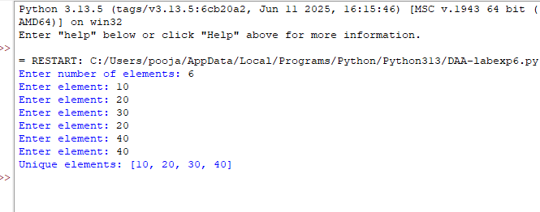
EXP 7. n = int(input("Enter number of elements: "))
arr = []
for i in range(n):
arr.append(int(input("Enter element: ")))
for i in range(n - 1):
for j in range(n - 1 - i):
if arr[j] > arr[j + 1]:
arr[j], arr[j + 1] = arr[j + 1], arr[j]
print("Sorted array:", arr)
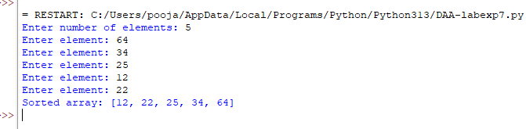
EXP 8. n = int(input("Enter number of elements: "))
arr = []
for i in range(n):
arr.append(int(input("Enter element: ")))
x = int(input("Enter element to search: "))
low = 0
high = n - 1
found = False
while low <= high:
mid = (low + high) // 2
if arr[mid] == x:
found = True
break
elif arr[mid] < x:
low = mid + 1
else:
high = mid - 1
if found:
print("Element found at index", mid)
else:
print("Element not found")
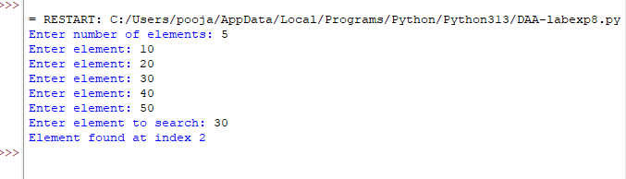

EXP 9. def merge_sort(arr):
if len(arr) <= 1:
return arr
mid = len(arr) // 2
left = merge_sort(arr[:mid])
right = merge_sort(arr[mid:])
result = []
i = 0, j = 0
while i < len(left) and j < len(right):
if left[i] <= right[j]:
result.append(left[i])
i += 1
else:
result.append(right[j])
j += 1
while i < len(left):
result.append(left[i])
i += 1
while j < len(right):
result.append(right[j])
j += 1
return result
n = int(input("Enter number of elements: "))
nums = []
for i in range(n):
nums.append(int(input("Enter element: ")))
nums = merge_sort(nums)
print("Sorted array:", nums)
